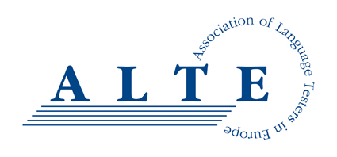
Conflict of Interest Policy

All staff, contractors, consultants, volunteers and management committee members of ALTE will strive to avoid any conflict of interest between the interests of ALTE on the one hand, and personal, professional and business interests on the other. This includes avoiding conflicts of interest as well as the perception of conflicts of interest.
The purpose of this policy is to protect the integrity of ALTE and those who work with and for ALTE, and to enable our stakeholders to have confidence in our integrity.
ALTE’s Constitution sets out its position on Conflicts of Interest and Conflicts of Loyalty for its Trustees in section 7:
7 Conflicts of interest and conflicts of loyalty

A charity trustee must:

7.1 declare the nature and extent of any interest, direct or indirect, which he or she has in a proposed transaction or arrangement with the CIO or in any transaction or arrangement entered into by the CIO which has not previously been declared; and

7.2 absent himself or herself from any discussions of the charity trustees in which it is possible that a conflict of interest will arise between his or her duty to act solely in the interests of the CIO and any personal interest (including but not limited to any financial interest).

Any charity trustee absenting himself or herself from any discussions in accordance with this clause must not vote or be counted as part of the quorum in any decision of the charity trustees on the matter.

The principles contained within section 7 of the constitution also applies to other staff, contractors, consultants, volunteers and management committee members (e.g. Standing Committee) of ALTE, in that a person appointed to a particular post or position should, if needed, make a full, written disclosure of interests that could potentially result in a conflict of interest, and any mitigating action that may be taken to avoid a conflict of interest, or a perception of a conflict of interest. The written disclosure will be kept on file and will be updated as appropriate.
The Procedures for Auditing Document sets out its position on Conflicts of Interest for auditors, and the most recent version of the document should be consulted if necessary.

This policy is meant to supplement good judgement, and staff, contractors, consultants, volunteers and management committee members should respect its spirit as well as its wording.

ALTE (Association of Language Testers in Europe) is a Charitable Incorporated Organisation, registered in England, Charity number 1184799.

